Pre-Production Planning Document (PODCAST)

GENERAL INFO

- Your Name: Nick Melanson
- PROJECT: Podcast

CREATIVE BRIEF

- What must it be? It will be a mini podcast episode breaking down the Mookie Betts trade between the Dodgers and the Red Sox.

- Who is it for? It is for sports fans, Boston, and LA fans.

- How long must it be? Between 2-10 minutes.

- What is your objective with the piece? I want to be able to affectively break down the blockbuster trade between the two teams, and I would like to name a “winner” of the deal.

- When is it due? The podcast episode is due at the end of Module 2.

- What is the overall idea? A podcast episode breaking down the Mookie Betts trade.

- What is the storyline summary? I will begin with talking about Mookie’s effect on the Red Sox. I will then talk about the trade that was done. From there, I will talk about the effect that the trade had on both the Red Sox and the Dodgers.

- Elevator pitch: What if I told you that would could go down as one of the biggest trades in MLB history actually might not have the winner that you think it did? The former MVP and future Hall of Famer Mookie Betts was sent to LA in a shocking move that left the Red Sox helpless, needing to fill the void that the superstar left behind. But what if the Red Sox were actually better off without him?

- Tagline: You Betts Believe

- Look and feel description: I want this to be a light podcast, with whimsical music and a friendly approach feel to it, almost as if you’re discussing the trade with a neighbor or a friend. Despite this however, I still want to be analytical and make sure that I establish my point and get my message across.

MIND MAP

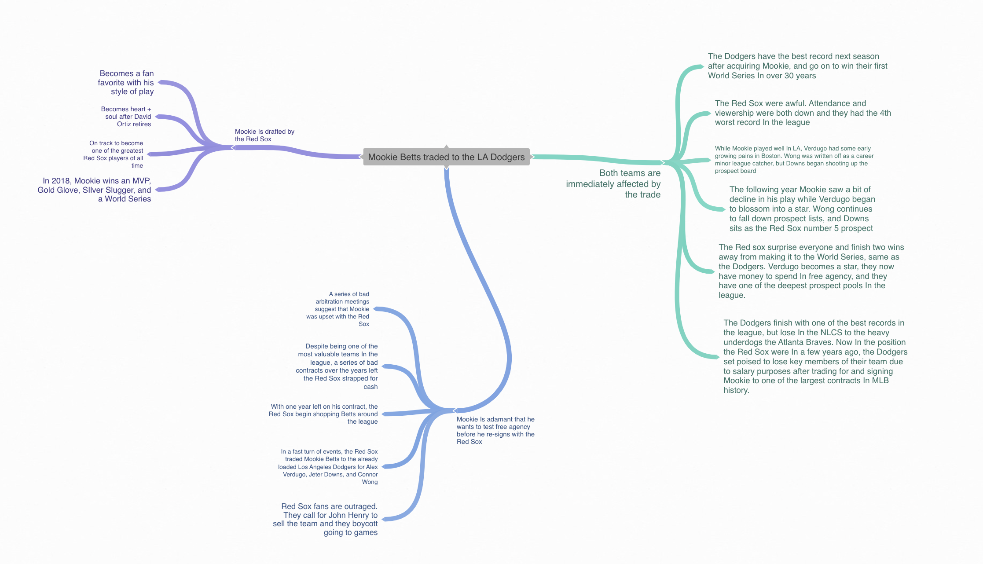

QUESTIONS / NOTES

HOOK:
- What will grab the attention of the audience within the first few seconds? Mentioning the name Mookie Betts – for Red Sox fans just his name alone is enough to make someone sit down and listen. Betts is also one of the most beloved players in the league, so I am confident that fans of any team would want to hear what I have to say.
- Hook ideas: Say that the Red Sox won the trade. – Most fans of baseball would disagree. I could also allege that the Red Sox are better off without him – which sounds crazy, but I am proposing it as true. I could also start off with a sound, maybe audio of Mookie winning a World Series with the Red Sox and another audio clip of him winning with the Dodgers.

MESSAGE/STORY:
- What message are you trying to deliver to the audience? I just want to tell a story about an MLB trade that affected my life, because I’m a huge Red Sox and Mookie Betts fan. Along the way, I want to show how the Red Sox didn’t get the short end of the stick as badly as everyone initially thought they did.
- Clearly describe the following parts of your story:
  - Beginning: Establishing who Mookie is, as well as his legacy with Boston and the Red Sox.
  - Middle: Discussing the actual parameters of the trade and who each team got.
  - End: Talking about how each team and player performed after the trade.

NARRATION/HOST:
- Who will lead us through the piece? Me
- Narration ideas: I want to sound lighthearted and make it seem almost as if im having a conversation directly with my listener.

MUSIC:
- What is overall “mood” and “feel” of the piece? I want to play some songs that make you think that you’re at a baseball game.
- Music track ideas: Maybe “Take Me Out to the Ball Game” or something like that.

AMBIENT AUDIO:
- What is the “location” of the piece? If we close our eyes, where should we imagine that we are? I want you to imagine that you’re sitting on a couch with your friend and you’re talking spports.
- Ambient audio ideas: I want to have some short sound affects in the background. I also want to play some music in the background as I talk.

SOUND EFFECTS:
- What sound effects (SFX) would help tell this story? Why? The sound of a baseball being hit. The roars of fans. I want to establish how important Mookie was to the city of Boston and its fans.
- SFX ideas: A baseball being hit, or the cheers of a crowd. Maybe I could find some Mookie MVP chants somewhere too.

(OPTIONAL) INTERVIEWS:
- Who will you interview? Nobody
- Why is this person important to the piece? None
- What questions will you ask? None
- What followup questions might be important? None

SCRIPT

Name: Nick Melanson
Title: You Betts Believe!

VIDEO | AUDIO
(NO VISUALS FOR AUDIO PROJECT) | Sample:  (Fade in ambient audio)  VOICE OVER:  (Bulleted points)  Start off with talking about Mookie Betts on the Red Sox.  X I remember when he was first called up to the MLB, while listening in the car with my dad.  (use sound fx of baseball being hit, crowd cheers)  X When Ortiz retired, Mookie was the heart and soul of the Red Sox.  X In 2018, Mookie won the MVP, a Gold Glove, a Silver Slugger, and the World Series. He established himself as a Boston legend, all at the age of 26.  X I always felt like Mookie was going to leave, but he loved Boston. The Red Sox began shopping him in trades.  X Mookie Betts was traded to the LA Dodgers along with David Price for Alex Verdugo, Connor Wong, and Jeter Downs.  X Mookie immediately signed a 12-year $365 million contract with the Dodgers after telling the Red Sox he would test free agency before signing a deal to stay.  (use emotion, emphasize my despair)  X In his first season with the Dodgers, Mookie put up respectable numbers while winning the World Series.  X The Red Sox had the 4th worst record in the league. Verdugo played alright, Jeter Downs became a Red Sox top prospect, and Connor Wong became one of the Red Sox top catching prospects.  X Now almost 2 years since the trade,  The Red Sox and the Dodgers were both two wins away from going to the World Series. Betts hasn’t played as well as he did on the Red Sox since joining the Dodgers, but Verdugo has started blossoming into a star. Wong has essentially fallen off the Red Sox prospect lists, while Downs sits as the 5th best prospect in the Red Sox system.  (Fade music up)  (Fade music and ambient out)

CREATE A PDF
When you are done creating this document, you should create a universal PDF document that can be easily posted to your blog or emailed (it’s not safe to assume everyone has Microsoft Word, and the files can be very large).

To do this on a Mac, click File>Print and then click the option for PDF in the lower left, followed by “Save to PDF”. Contact me if you need help on a PC.

